Educational Gaps Limit Brazil’s Reach
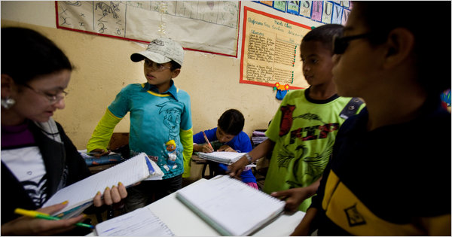
André Vieira for The New York Times
A school in Caetés, Brazil, President Luiz Inácio Lula da Silva’s hometown.

By ALEXEI BARRIONUEVO

Published: September 4, 2010


CAETÉS, Brazil — When Luiz Inácio Lula da Silva was sworn in as Brazil’s president in early 2003, he emotionally declared that he had finally earned his “first diploma” by becoming president of the country.

Multimedia
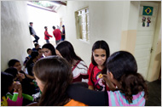Audio Slide Show

A Gap Lula Could Not Close
Enlarge This Image
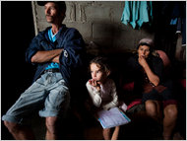

André Vieira for The New York Times
Maria and José Bezerra da Silva live with their seven children in Caetés. Unable to read, they cannot help with schoolwork.
One of Brazil’s least educated presidents — Mr. da Silva completed only the fourth grade — soon became one of its most beloved, lifting millions out of extreme poverty, stabilizing Brazil’s economy and earning near-legendary status both at home and abroad.
But while Mr. da Silva has overcome his humble beginnings, his country is still grappling with its own. Perhaps more than any other challenge facing Brazil today, education is a stumbling block in its bid to accelerate its economy and establish itself as one of the world’s most powerful nations, exposing a major weakness in its newfound armor.
“Unfortunately, in an era of global competition, the current state of education in Brazil means it is likely to fall behind other developing economies in the search for new investment and economic growth opportunities,” the World Bank concluded in a 2008 report.
Over the past decade, Brazil’s students have scored among the lowest of any country’s students taking international exams for basic skills like reading, mathematics and science, trailing fellow Latin American nations like Chile, Uruguay and Mexico.
Brazilian 15-year-olds tied for 49th out of 56 countries on the reading exam of the Program for International Student Assessment, with more than half scoring in the test’s bottom reading level in 2006, the most recent year available. In math and science, they fared even worse.
“We should be ashamed of ourselves,” said Ilona Becskeházy, executive director of the Lemann Foundation, an organization based in São Paulo devoted to improving Brazilian education. “This means that 15-year-olds in Brazil are mastering more or less the same skills as 9-year-olds or 10-year-olds in countries such as Denmark or Finland.”
The task confronting the nation — and Mr. da Silva’s legacy — is daunting. Here in this dirt-poor northeastern town, where Mr. da Silva lived his first seven years, about 30 percent of the population is still illiterate, a figure three times higher than the national rate.
When Mr. da Silva was a boy here, his father used to beat some of his older siblings when they went to school instead of working, said Denise Paraná, the author of a biography of the president.
Today, teachers say that many parents send their children to school only because school attendance is a requirement of the Bolsa Familia subsidy program that Mr. da Silva has greatly expanded under his watch, which provides up to about $115 a month per family.
But even with the added incentive, reading levels vary so greatly here that in one eighth-grade classroom, students from 13 to 17 all read aloud from the same text.
“A lot of parents say, ‘Why should they study if there are no opportunities?’ ” said Ana Carla Pereira, a teacher at another rural school here.
As president, Mr. da Silva’s own education policies got off to a slow start; he dismissed two education ministers before settling on one in 2005. Then the government’s educational program did not start until 2007 — four years after Mr. da Silva took office.
Now in his last year in office and talking about his place in history, Mr. da Silva has an “obsession” with the issue, his education minister, Fernando Haddad, said, which was plain to see when he recently returned here to his childhood town.
“I want every child to study much more than I could, much more,” he said while announcing a program to give laptops to students. “And for all of them to get a university diploma, for all of them to have a vocational diploma.”
The urgency could hardly be clearer. Brazil has already established itself as a global force, riding a commodity and domestic consumption boom to become one of the largest economies in the world. With huge new oil discoveries and an increasingly important role in providing food and raw materials to China, the country is poised to surge even more.
But the nation’s educational shortcomings are leaving many Brazilians on the sidelines. More than 22 percent of the roughly 25 million workers available to join Brazil’s work force this year were not considered qualified to meet the demands of the labor market, according to a government report in March.
“In certain cities and states we have a problem hiring workers, even though we do have employment,” said Márcio Pochmann, president of the Institute for Applied Economic Research, the government agency that produced the March report. Earlier estimates showed that tens of thousands of jobs went unclaimed because there were not enough qualified professionals to fill them.
Unless that gap is filled soon, Brazil may miss its “demographic window” over the next two decades in which “the economically active population is at its peak,” the World Bank said.
Dr. Haddad, the education minister, said that while Brazil still performed poorly compared with other countries, it was improving faster than many competitors.
- 1
- 2
Next Page »
Myrna Domit contributed reporting from São Paulo, Brazil.

